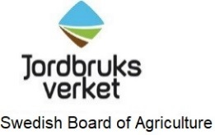  Plant and Environment Department  Anette Palm  E-post: vaxtinspektionen@jordbruksverket.se | letter  8-5-2019 |  | Dnr 6.4.18-07630/2019
 | To whom it may concern

N K Lundströms Trävaror Aktiebolag
N K Lundströms Trävaror Aktiebolag with production site Tväråbäck 20 in Vännäs, registration number 556107-8154, is authorized by the Swedish Board of Agriculture to use and apply the ISPM 15mark on wood packaging material and pieces of wood that are to be made into wood packaging material, and to use and apply the KD 56ºC/30 min mark on sawn wood products.
According to the Swedish decision dated 18 January 2006, reference number S20 4/06 the company´s official registration number is SE-AC37.
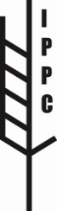
SE –AC37
HT

SE-AC37

The conditions for permit and withdrawal are given in the Swedish Regulation (SJVFS 2014:39) on labelling of wood or wood packaging material with health certificate. Note that the permit does not have a time limit.
The latest updated information on companies with permit to label in accordance to the Swedish Regulation (SJVFS 2014:39) can be found at www.jordbruksverket.se/wpm and www.jordbruksverket.se/sawnwood

Anette Palm

The certificate has been signed digitally and therefore lacks a written signature.

International Standard for Phytosanitary Measures no. 15, Regulation of Wood Packaging Material in International Trade.

